School of Computer Science and Artificial Intelligence

Lab Assignment # 8.2

Program : B. Tech (CSE)
Specialization : AIML
Course Title : AI Assisted Coding Course Code:
23CS002PC304
Semester : VI
Academic Session : 2025-2026
Name of Student : Nitesh Kumar
Enrollment No. : 2303A52098 Batch No. : 33
Date : 10/02/26

Task 1 – Even/Odd Number Validator
Step 1: Test Cases (written first)
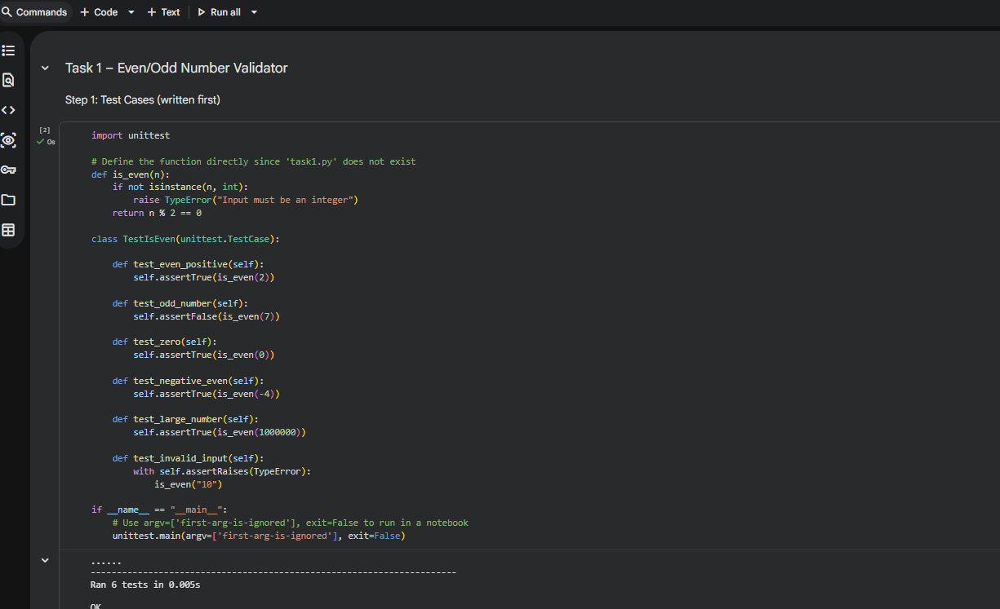
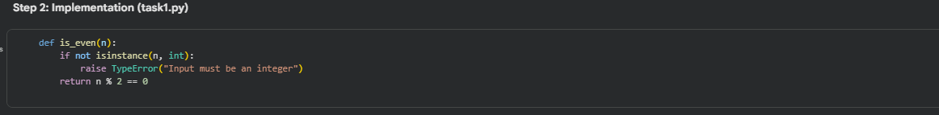
Task 2 – String Case Converter
Step 1: Test Cases
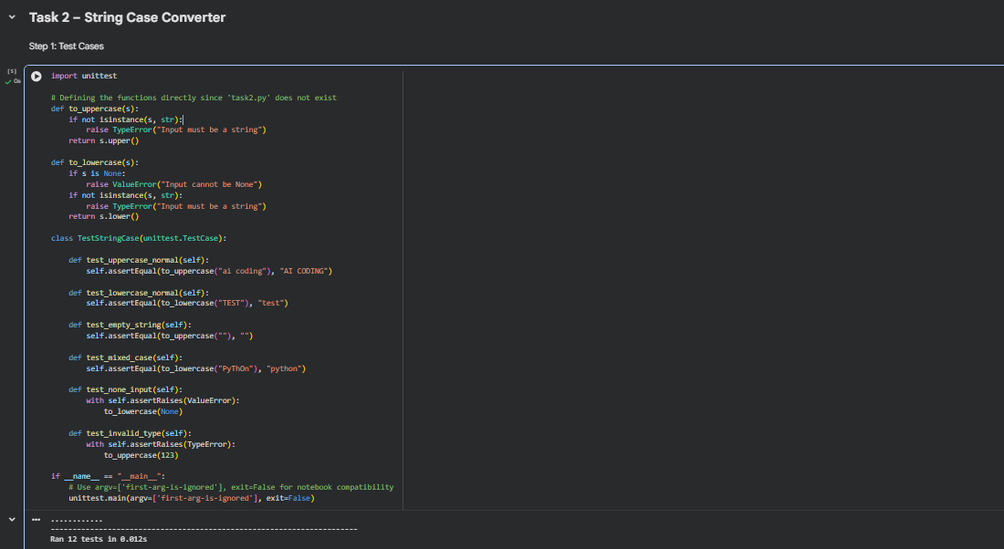
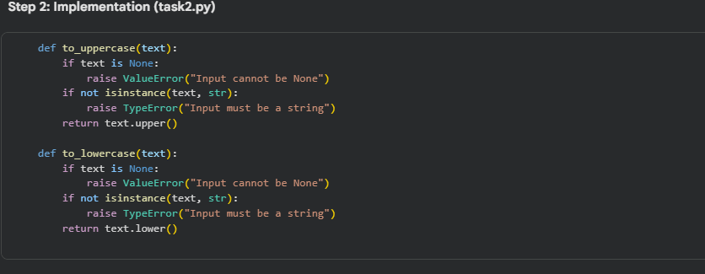

Task 3 – List Sum Calculator
Step 1: Test Cases
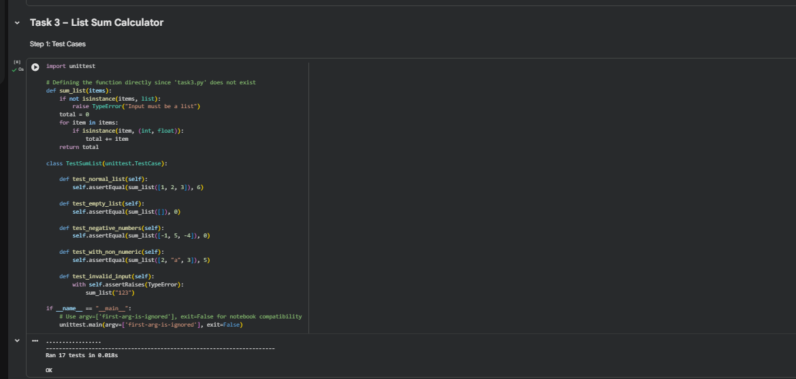
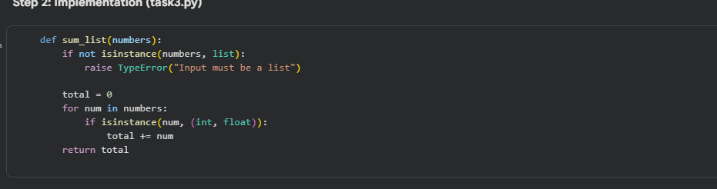
Task 4 – Student Result Class
Step 1: Test Cases
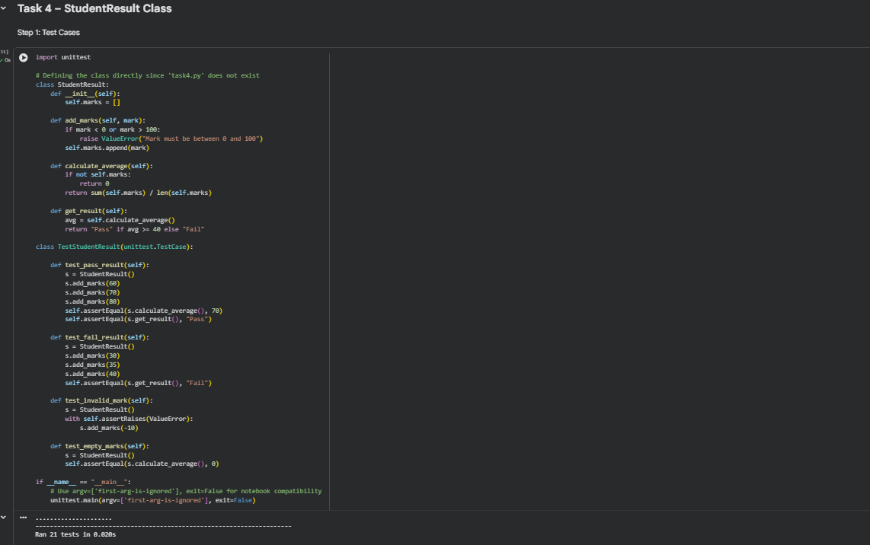
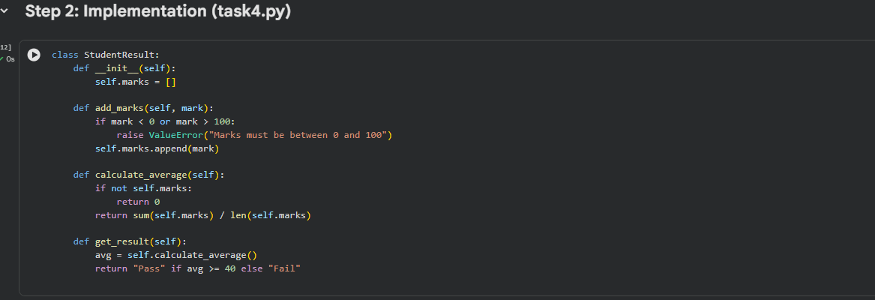
Task 5 – Username Validator
Step 1: Test Cases
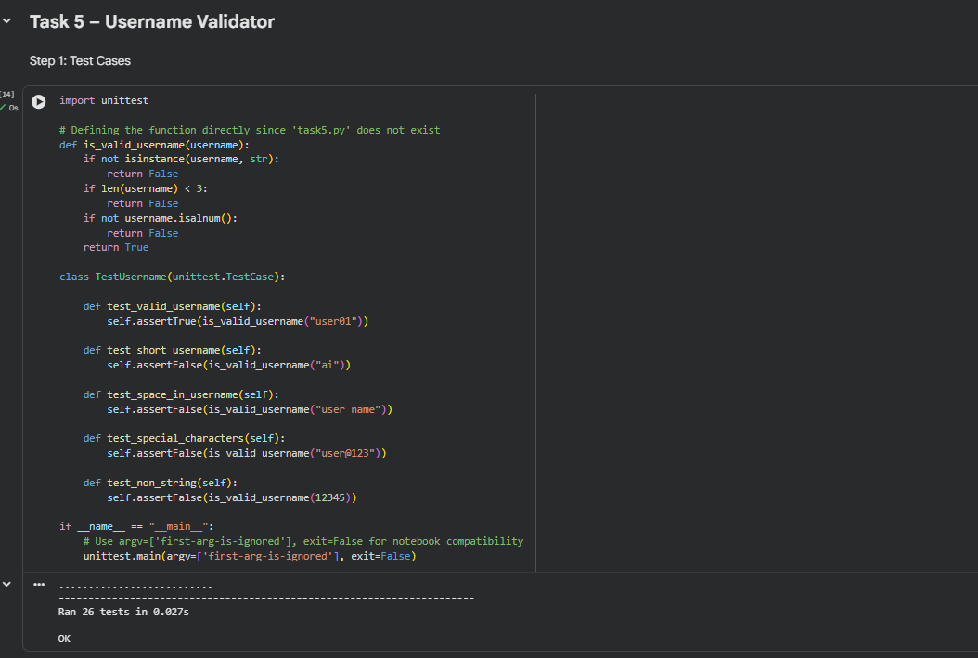
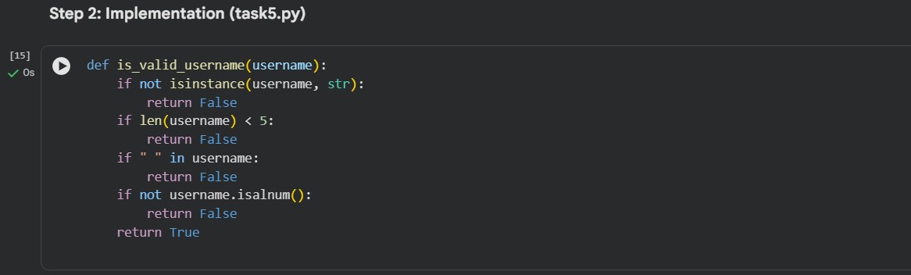
Lab Outcomes Covered
- Test cases written first (TDD style)
- Input validation & error handling
- Edge cases: empty, None, negative, large values
- unittest usage
- Clean and reliable implementations

